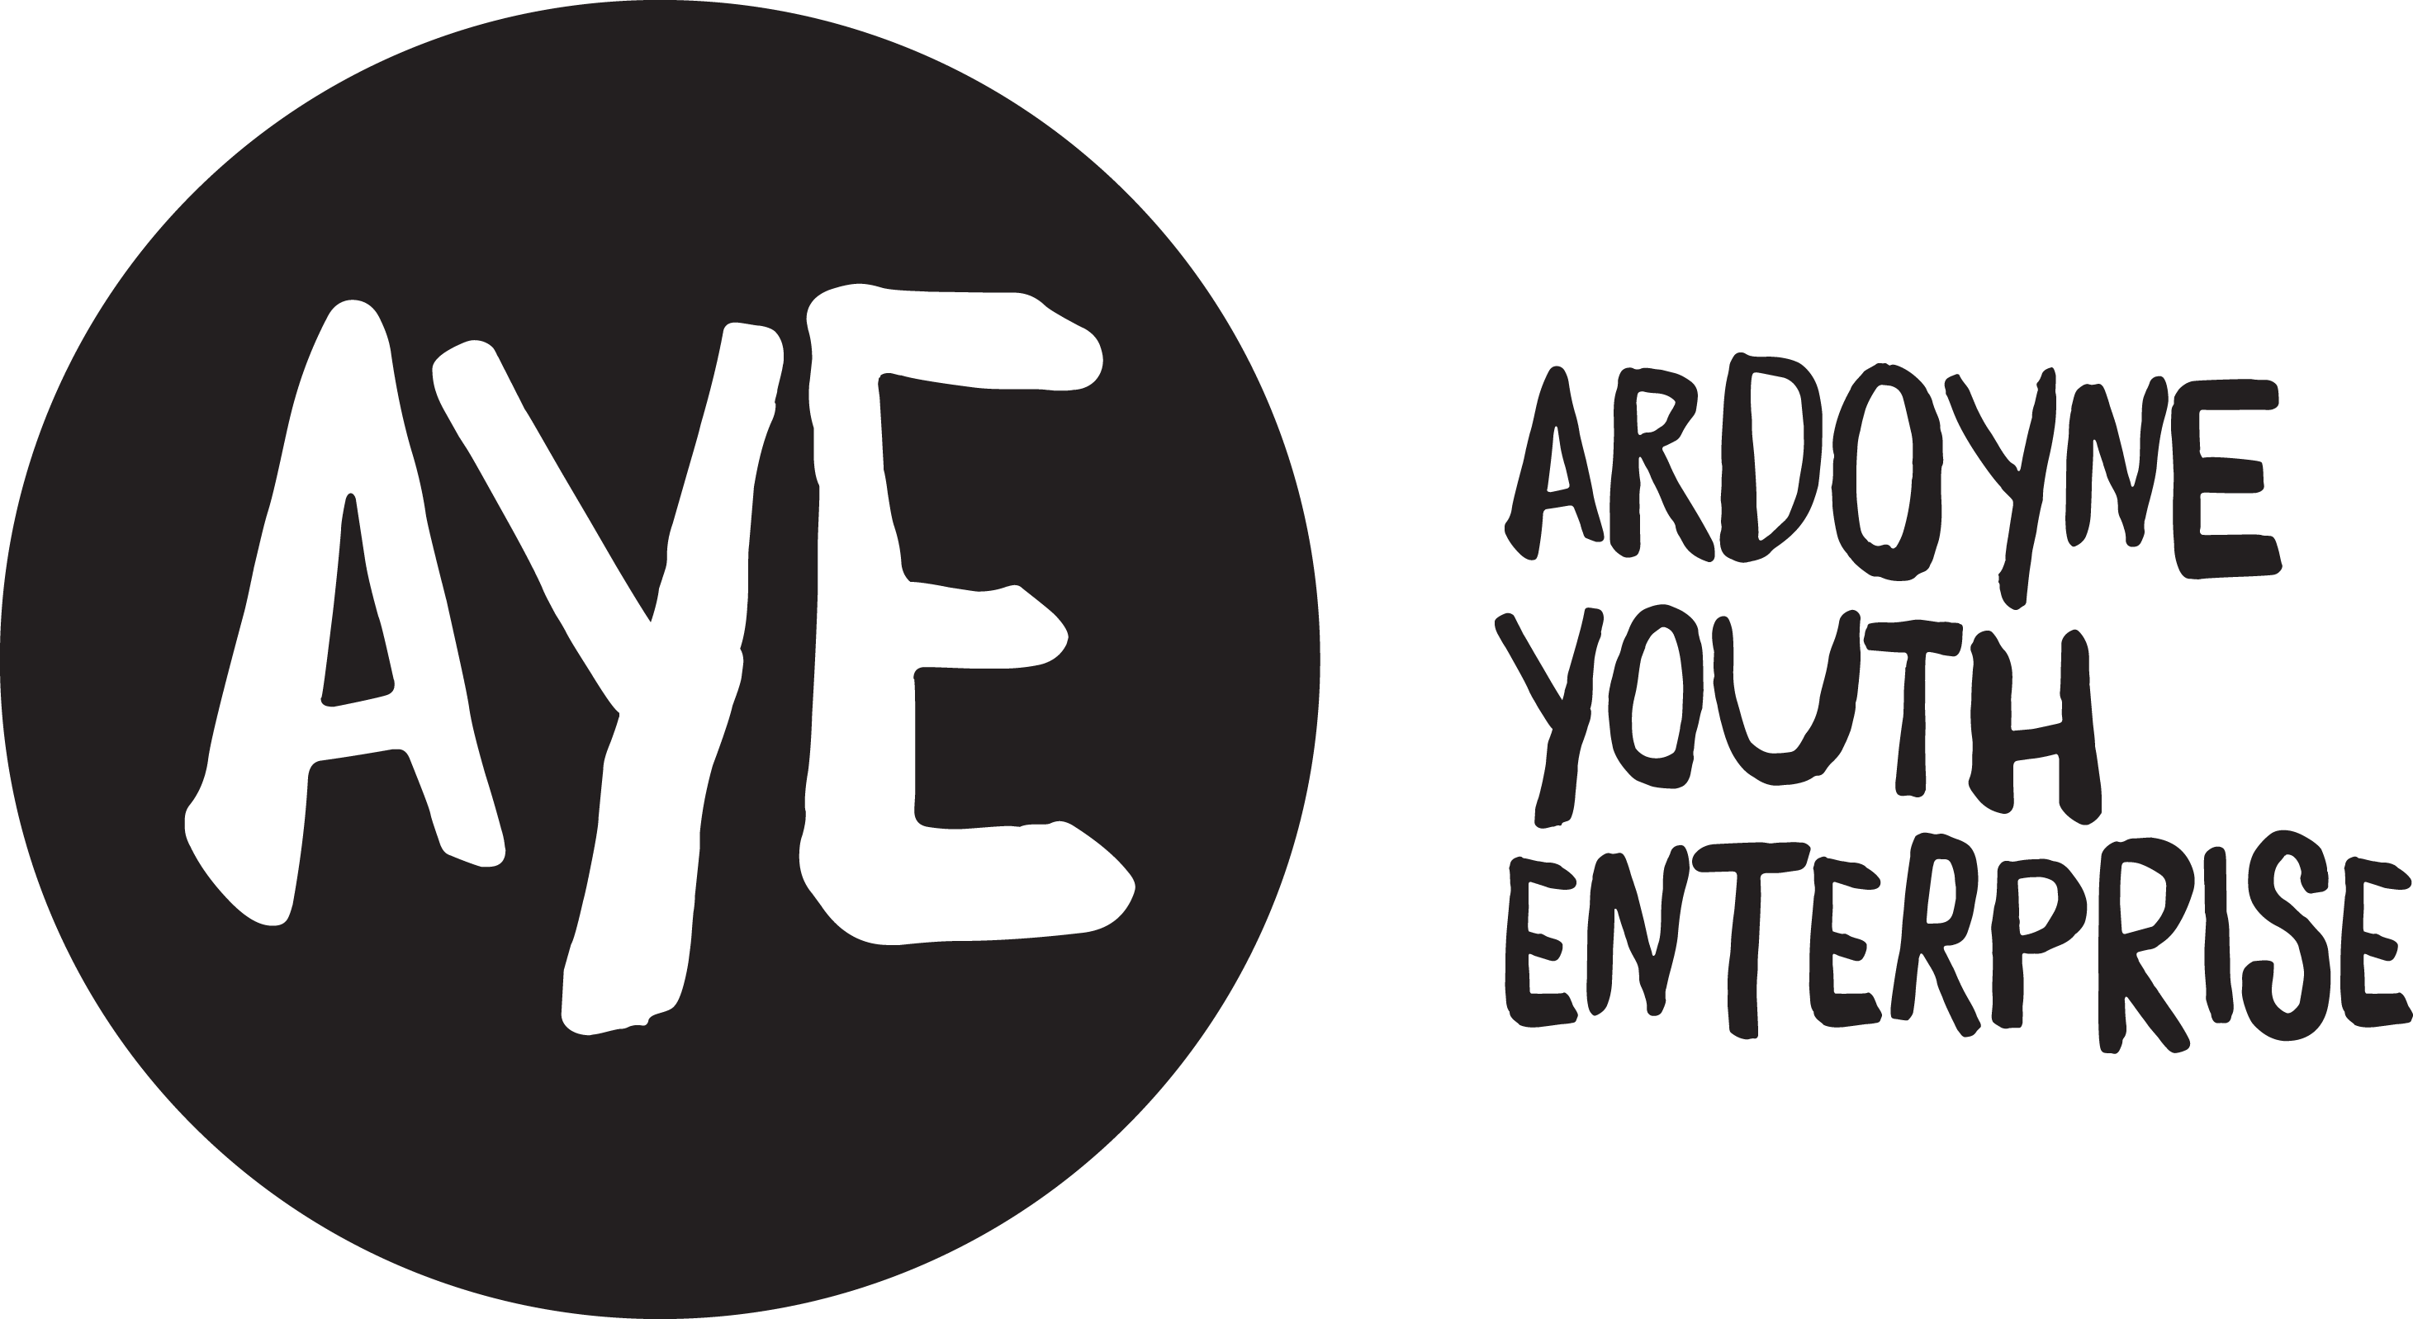

ARDOYNE YOUTH ENTERPRISE VOLUNTEER POLICY

AYE welcomes the participation of volunteers in its work, and will do its best to ensure that the time they spend with AYE contributes to their personal development and fulfilment.

Types of AYE volunteers and tasks
AYE volunteers fall into three categories:
- The AYE Executive Committee – the Executive Committee is the Board of Directors of AYE and is composed entirely of people who serve in a voluntary capacity.
- Those from member organisations or elsewhere who serve on working groups and sub-committees.
- Those who become involved in particular projects of AYE on a day to day basis and work in the main alongside or under the direction of AYEs paid staff.
We cannot always take up volunteering offers, but we do welcome enquiries, and we outline below the type of projects in which volunteers could be involved.
Opportunities for voluntary work within AYE will tend to be in the following areas:
- Administration/ICT
- Supporting the Youth Engagement Team
- Research and training
- Promotion and marketing
AYE will do its best to ensure that volunteers are satisfied in their work, and that all necessary support is available during the volunteer period. We will therefore ask all potential volunteers to complete a registration form, may ask for referees to be nominated, and will inform a volunteer when engaged to which particular member of staff he/she is accountable and may refer to for guidance and support. There are a number of points that you should consider when you become a volunteer, and to help you we have listed some of these below.

Time involved
Before making commitments, you should be reasonably certain that you can give whatever time is required. Sometimes this will be one hour or morning, sometimes on shift with the Youth Engagement Team for short defined period in the vening, or for an indefinite time-span.

Tasks involved
It is useful to be clear from the beginning why you are involved and what you can expect and what is expected of you. You can avoid possible misunderstandings later by discussing this with your supervisor.

Responsibilities
You should know to whom you are responsible. It will be to this person that you will refer for advice on any aspect of your work.

Regular attendance
It is vital that you do not repeat things you know or overhear as a result of your work. It is also important that if you are asked by the media for information on your work, you refer this to the Communications Officer in AYE.

Regular attendance
It will be possible to arrange your work according to the hours you wish to give, but reliability (including good time-keeping) will be expected. If for any reason you cannot attend when expected, give as much notice as possible.

Holidays
Please let your supervisor know if you are going to be on holiday so that alternative arrangements can be made during your absence.

Insurance
Whilst working with AYE, you will have the same insurance cover that is provided for members of staff.

Expenses
You will not receive pay or honoraria whilst working with AYE. You will be entitled to expenses as set out below, but only when these are necessarily incurred during your working hours:
Travel: if you do not use your own car, you will be reimbursed all costs incurred in using public transport. If you use your own car, you will be paid a mileage allowance at the rate applying from time to time. Rates are available from the Director.
Subsistence: if your work requires absence from AYEs office, you will be entitled to:
- A lunch allowance at the rate notified by your supervisor.
- An allowance for dinner and overnight accommodation when appropriate.
Telephone: if your work involves use of your home telephone, you will receive an allowance for calls made on AYE business. This allowance is at a prescribed rate per minute.
Claims: you will be required to keep a detailed record of all expenses incurred, and to submit to your supervisor at agreed intervals a claims form in respect of these expenses, accompanied by receipts. You will appreciate that expenses cannot be paid unless this procedure is followed.
Social Security Benefits: volunteering should not affect any social security benefits to which you are entitled, but to be absolutely certain about your position, you should check with your local Jobs and Benefits office before committing yourself to voluntary work with AYE. ‘Volunteering while on benefits’ on NI Direct website tells you about voluntary work and benefit entitlement: https://www.nidirect.gov.uk/articles/volunteering-while-benefits

Preparation and induction
For some projects there will be a preparation or induction course which is designed to help you begin voluntary work in the best way.

Support and training
All volunteers need some support and this may come in a variety of ways and from different people. If you do however feel isolated, uncertain or unhappy, let your supervisor know as soon as possible. Training may also be provided and if there is a course that would help your work, it may be possible that AYE can help with the cost of it.

Disability
In accordance with the Disability Discrimination Act a person is disabled if they have, or have had, “a physical or mental impairment which has, or has had, a substantial and long term adverse effect on your ability to carry out normal day to day activities.”
If volunteers consider themselves to have a disability relevant to the volunteer post or voluntary work they are undertaking they should make their supervisor aware so that specific arrangements, reasonable adjustments or adaptations can be made where possible, to assist the volunteer in completing the duties of the volunteer post.

Relationships between volunteers and paid staff
AYE supports good practice in volunteer/paid staff relationships. The following sets out good practice guidelines for the guidance of volunteers, which AYE fully subscribes to:
- Voluntary work should complement the work of paid staff, not substitute it.
- The employment or actions of volunteers should not threaten the livelihood of paid staff.
- Volunteers should not normally receive financial reward (other than out of pocket expenses).
- Paid staff should be made aware of all proposed volunteer involvement. Any changes in the level or extent of voluntary work should be preceded by full consultation amongst interested parties.
- There should be recognised machinery for resolution of problems between paid staff and volunteers.
- In the event of industrial action in the workplace, volunteers should not be required to undertake more voluntary work than they would do in normal circumstances.
- Volunteers should not cross a picket line which objects to their attendance or presence, but should discuss the situation with their supervisor who should in turn refer the matter to management/union negotiation.

Finishing volunteering
If you find a permanent job or for some other reason wish to stop volunteering, AYE will appreciate as much notice as possible of your intentions. If you do not find the particular project in which you are involved satisfactory, it may be possible to arrange alternatives. Do not hesitate to consult your line manager.

